A

REPORT

ON

BASANTA UTSAB

SRSSION 2023- 2024

DEPARTMENT OF PHILOSOPHY

Rabindra Mahavidyalaya,

Champadanga,Hooghly

Theme: BASANTA UTSAB2024

Venue: Rabindra Mahavidyalaya, champadanga

Department of Philosophy,

room no. 71

Date: 2ND April 2024

Organizer: Department of Philosophy

Objectives:

- To introduce the students to our culture, our traditions and to create its successors.
- To create a harmonious relationship by going beyond this teacher-student
- Teaching to spread love to each other through colors.
- Forgetting all differences, learning to unite in unity.

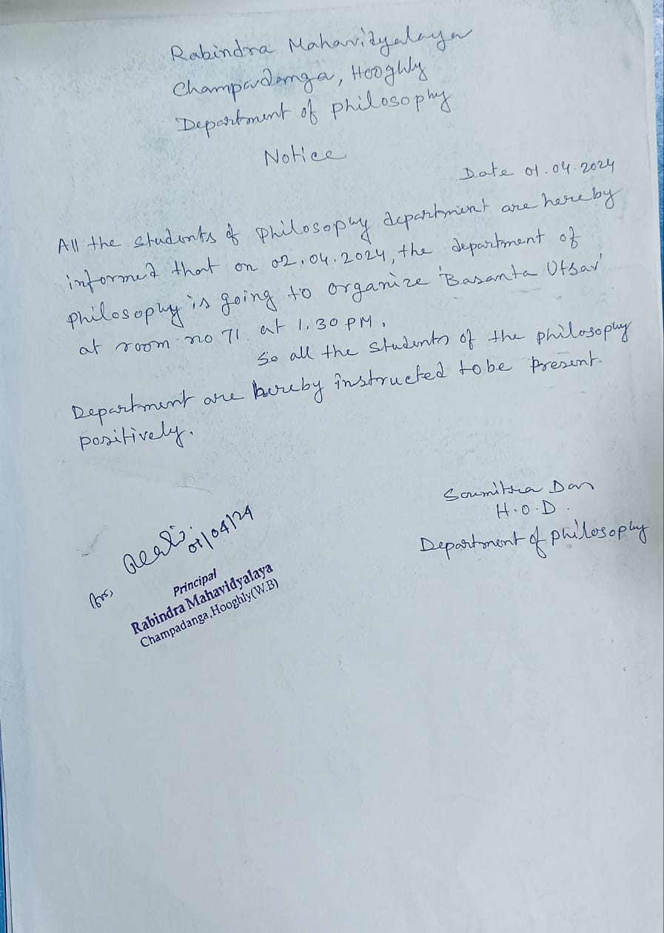

Summary:

BasantaUtsab was organized by Philosophy Department on 2NDApril 2024.A student
seminar was also organized on the same day. First, there is a student seminar. Then thespring festival begins. Everyone arrives at room No 71 for the Spring Festival
event. Professor Soumitra Das, Head of the Department of Philosophy, garlanding and lit a lamp in frontof Rabindranath portrait at the beginning of the event.Then every professor of
philosophy department, started the program auspiciously by putting color in front of the
portrait. All the professors of the department were welcomed by the students with
flowers and sandalwood drops. the whole program was filled with various activities like
dance song recital etc. During the programmed, professors from other departments, non
teaching staff, librarians come and are welcomed with flowers and sandalwood drops.

Another attraction on this day was the price distribution.Prizes are given to meritorious
students of three years.It wasfirst started this year by the alumni association. The student with the highest attendance is also awarded. It wasfirst started this year by the department oh philosophy.

Prize for result:
- RIMA SASMAL (1st position for 4THsem final result)
- SHRABANI GHOSH (1st position for 3rdsem final result)
- RDHASRI PANJA (1st position for 3rdsem final result)
- BACCHU MAHATO (1st position for 2NDsem final result)
- ITI SAMANTA (1st position for 1STsem final result)

Prize for ATTENDENCE:
- TRIPTI ADHIKARI (for 5thsem attendance)
- ANITA PATRA (for 3RDsem attendance)

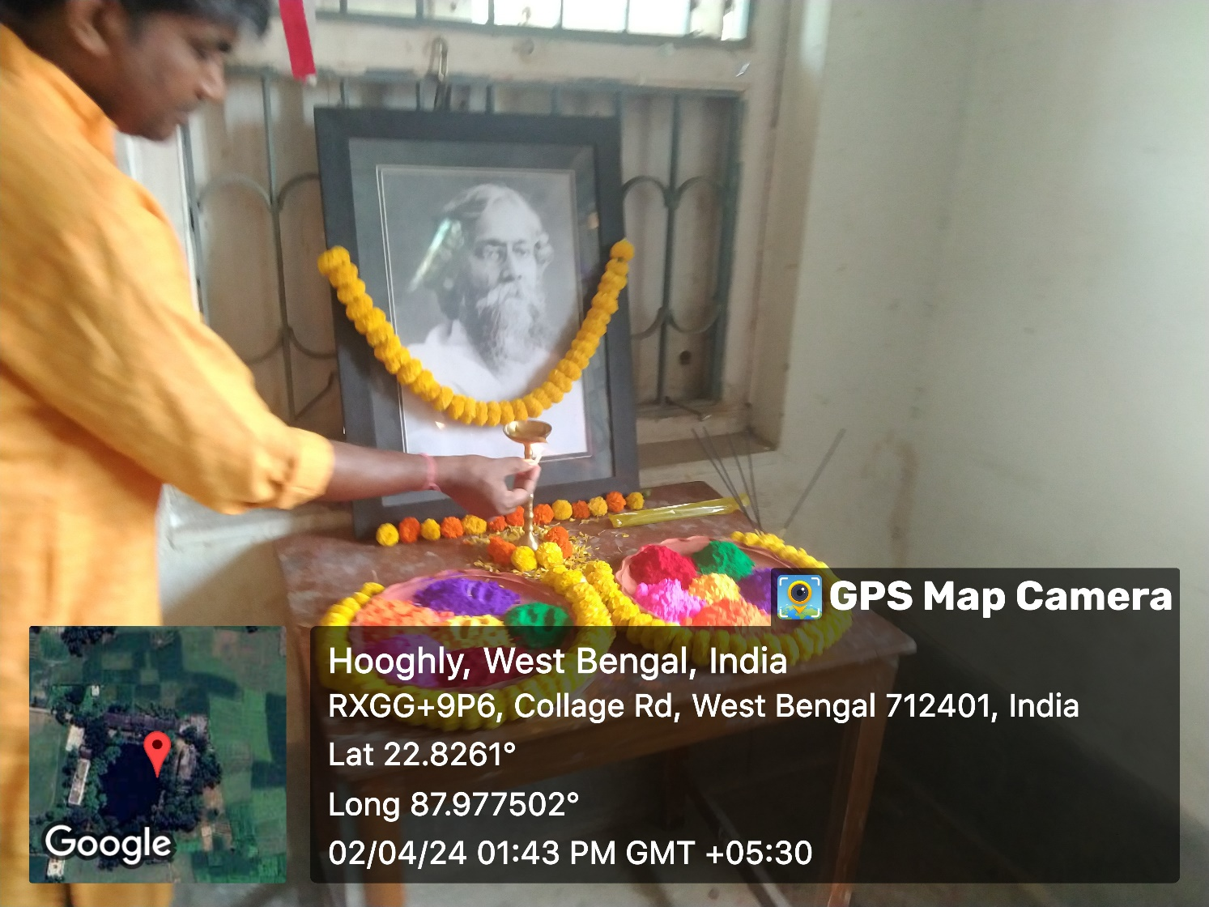
Lamp lighting and garlanding by department head prof. Soumitra Das
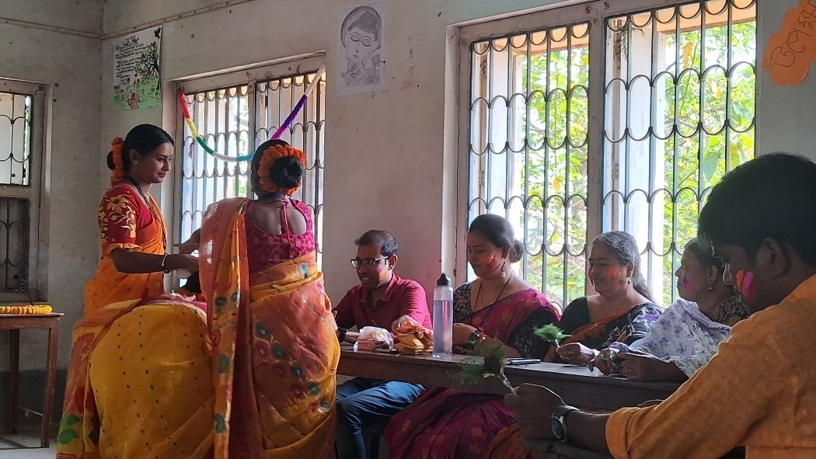
Welcome to teachers
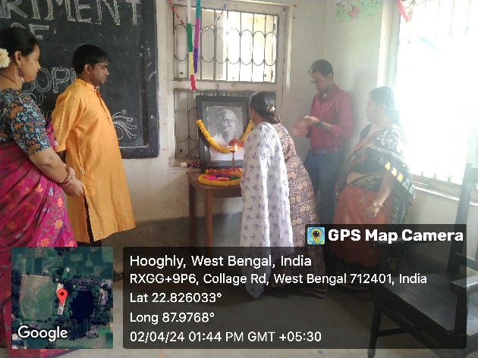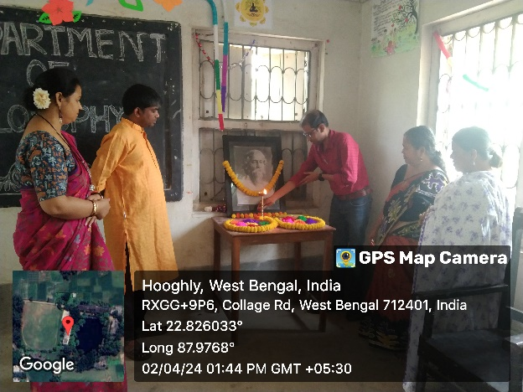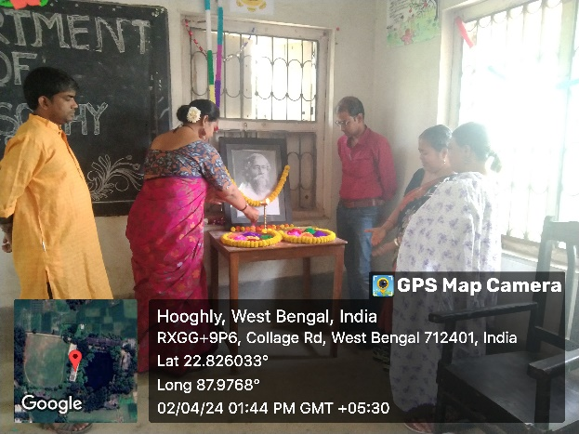
Inaugural session by the departmental professors

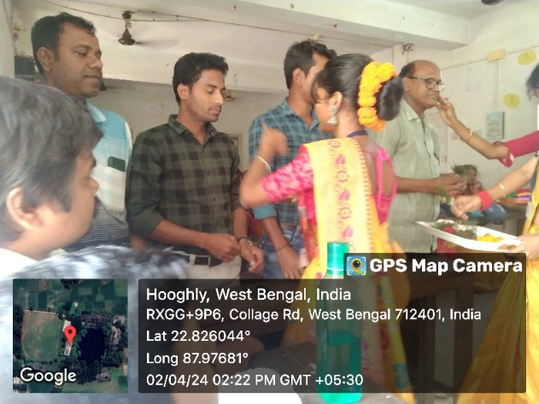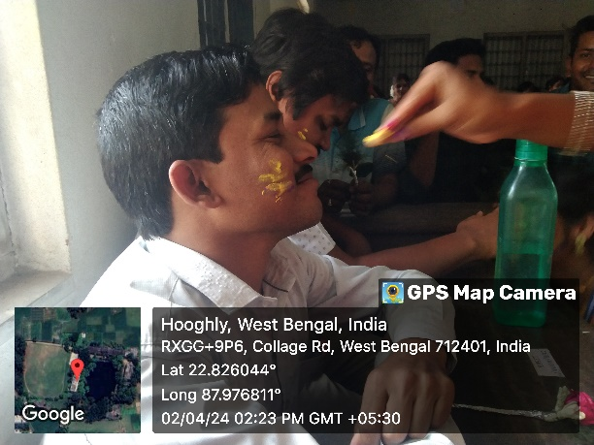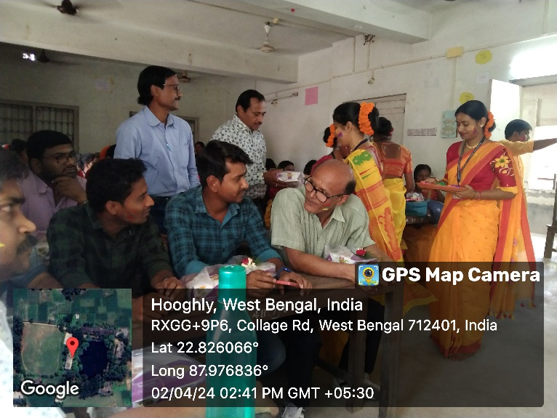
Welcome other departmental professors
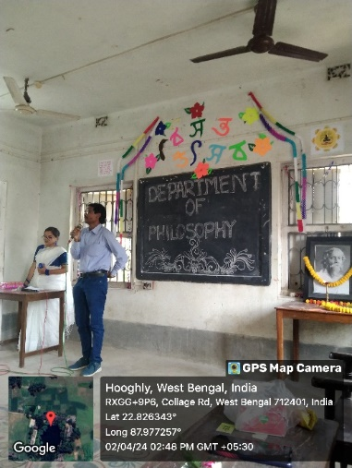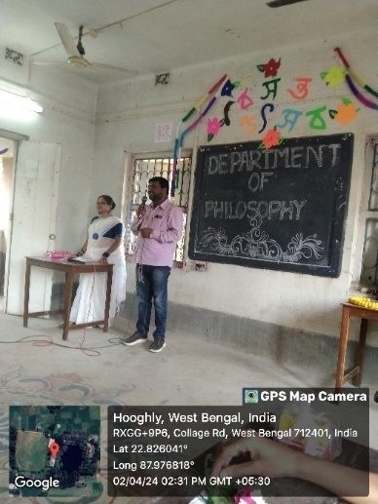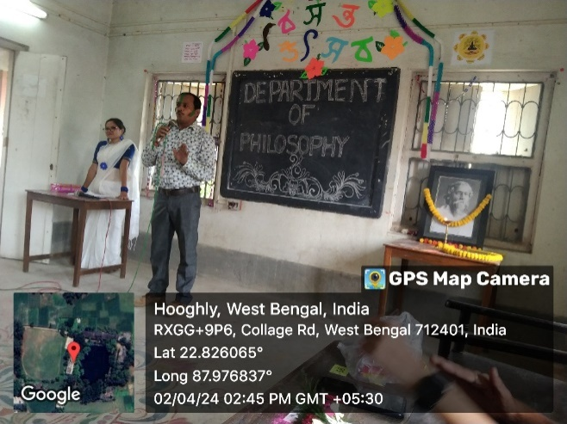
Speeches by other depaartmental professors
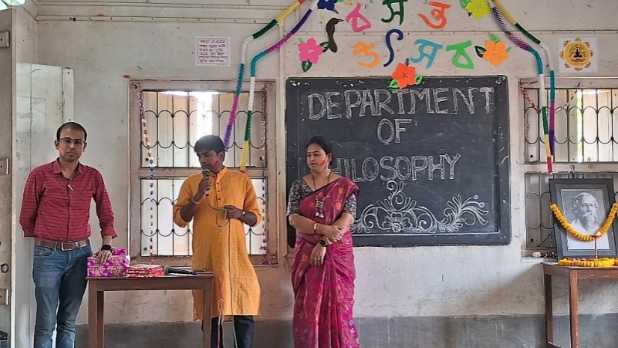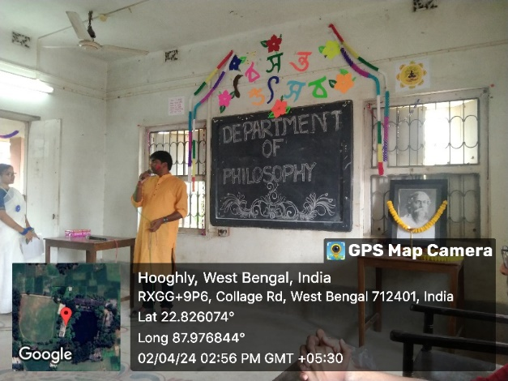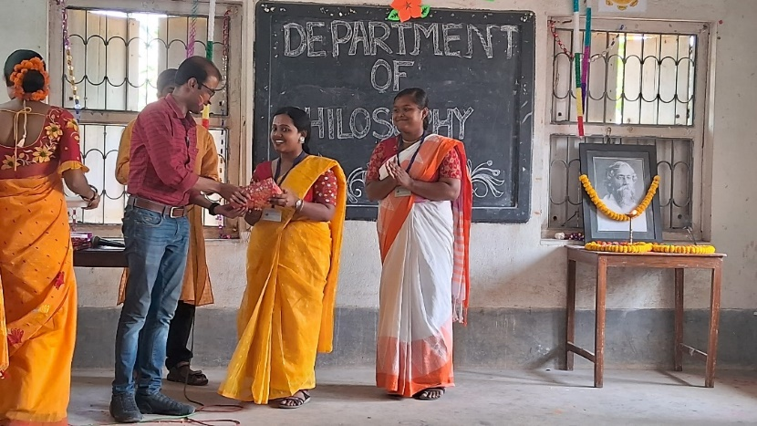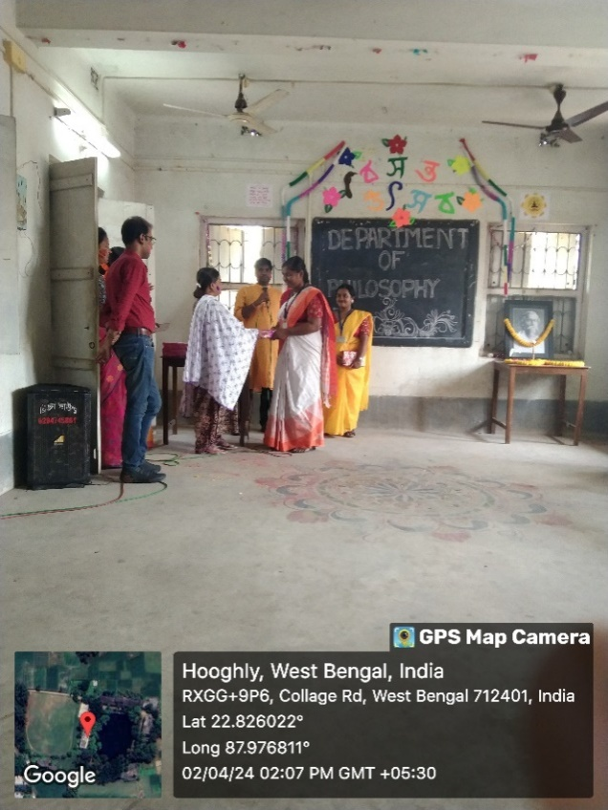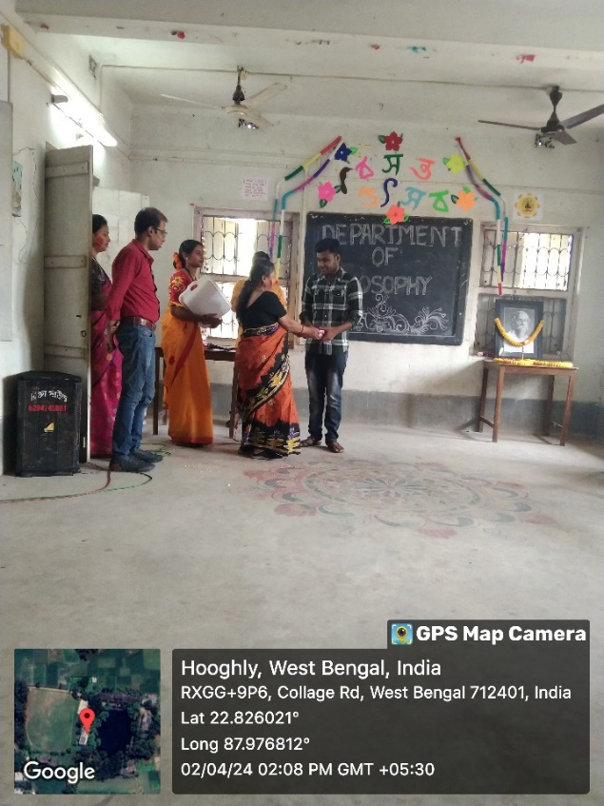
prize distribution ceremoney for meritorious students
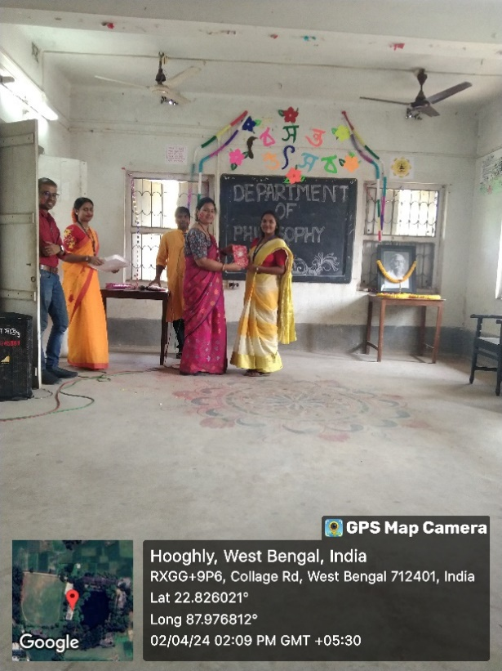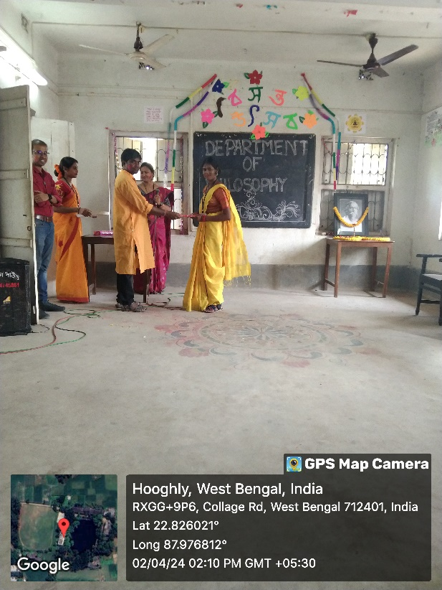
prize distribution ceremoney for highest attendent students

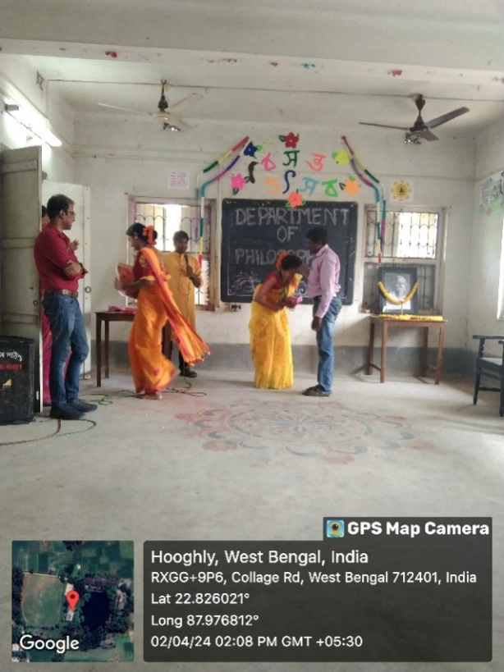
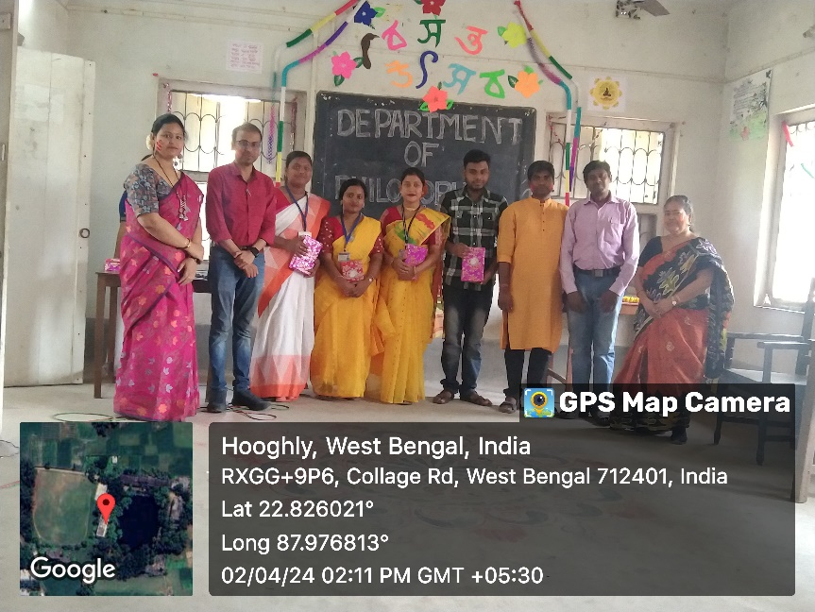
With ourmeritorious students
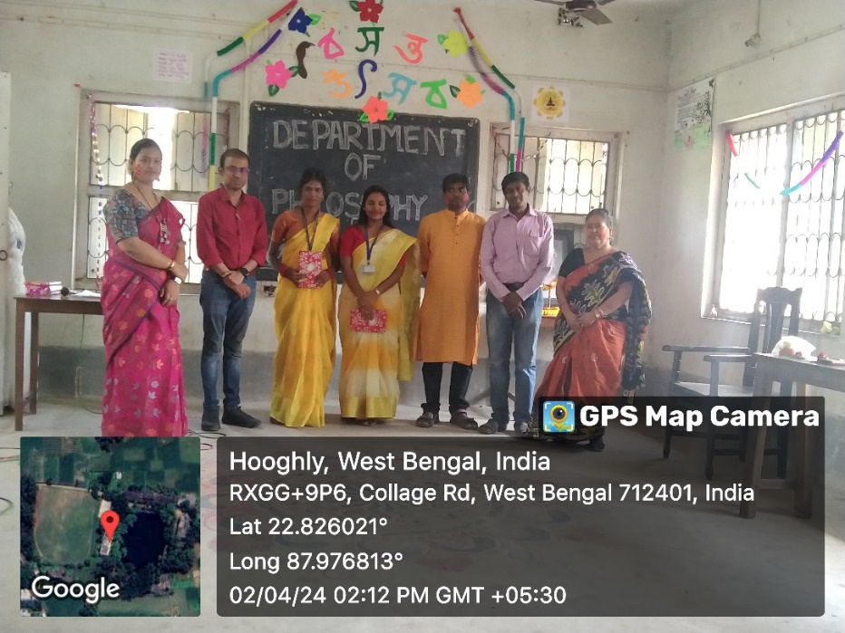
with the highest attendant students
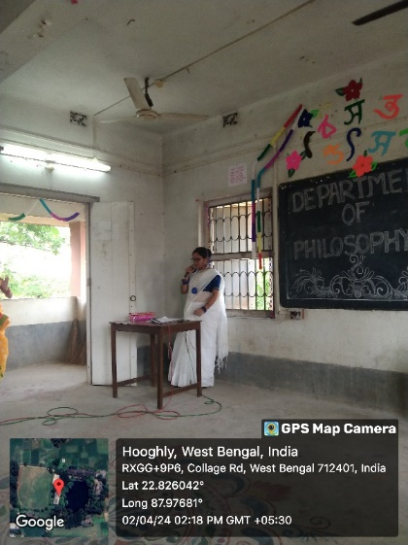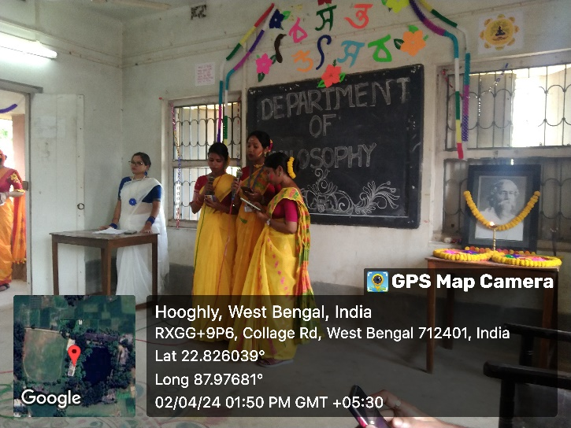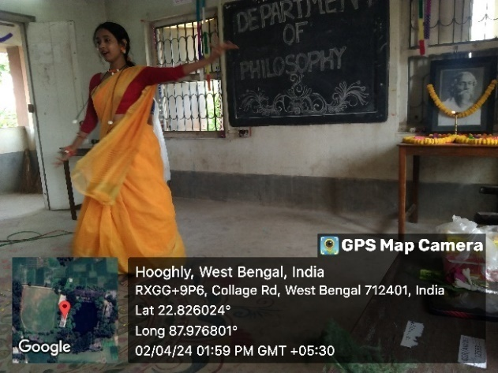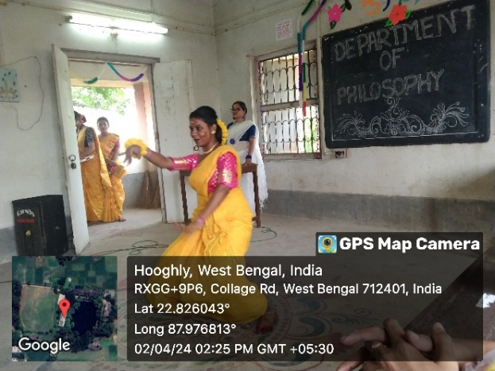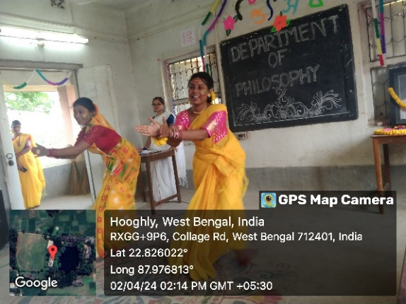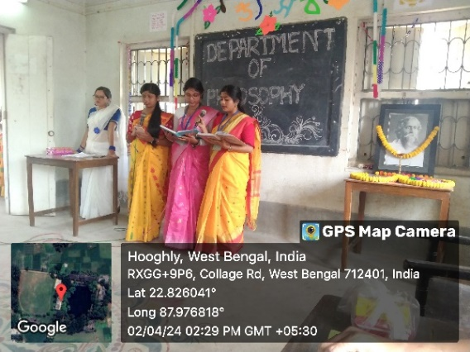
Coultural program by our students

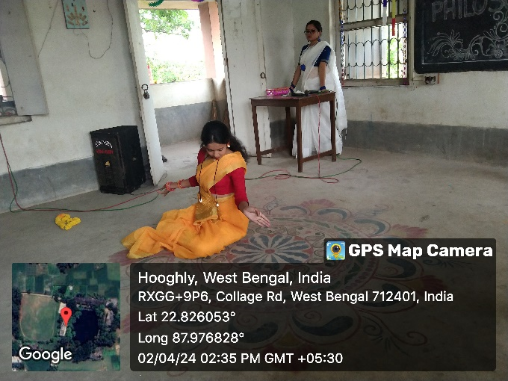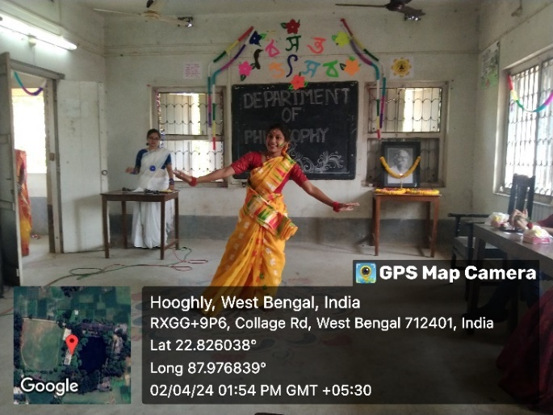Coultural program by our students

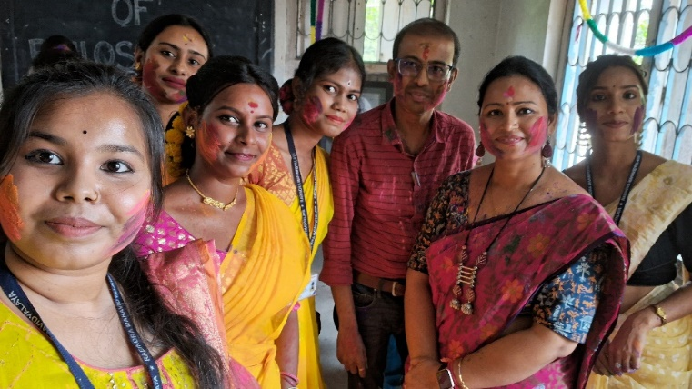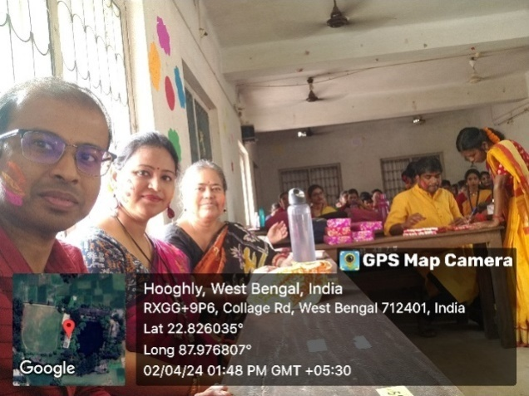
SOME GLIMPS

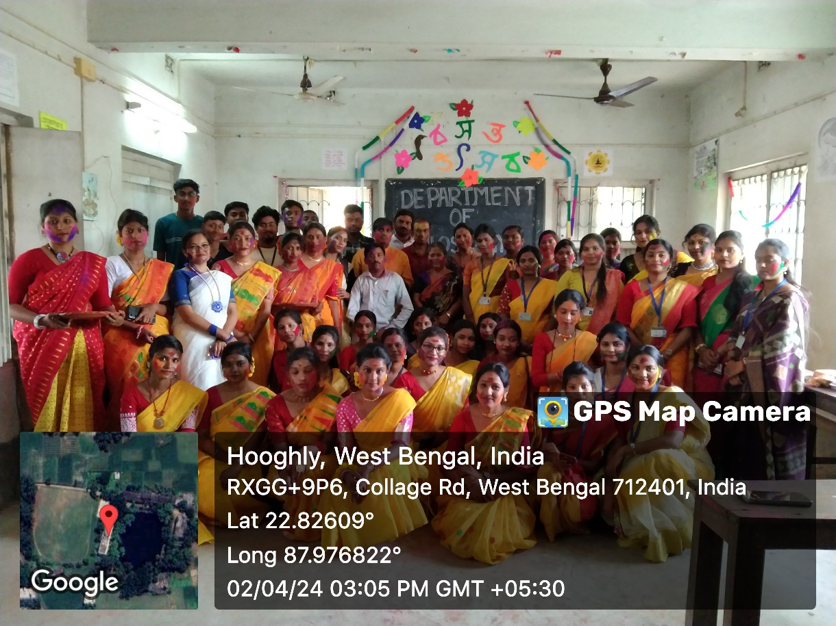
With our students

Attendence
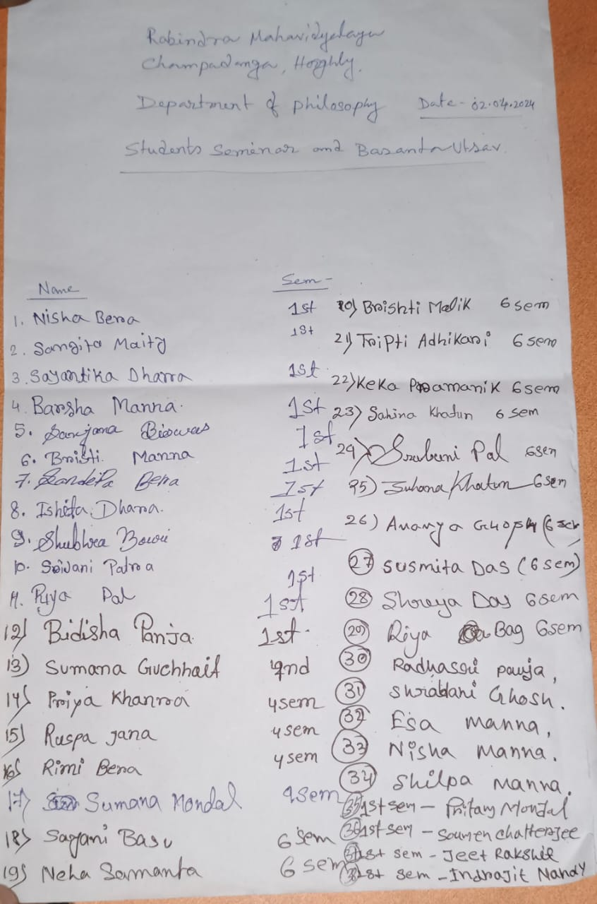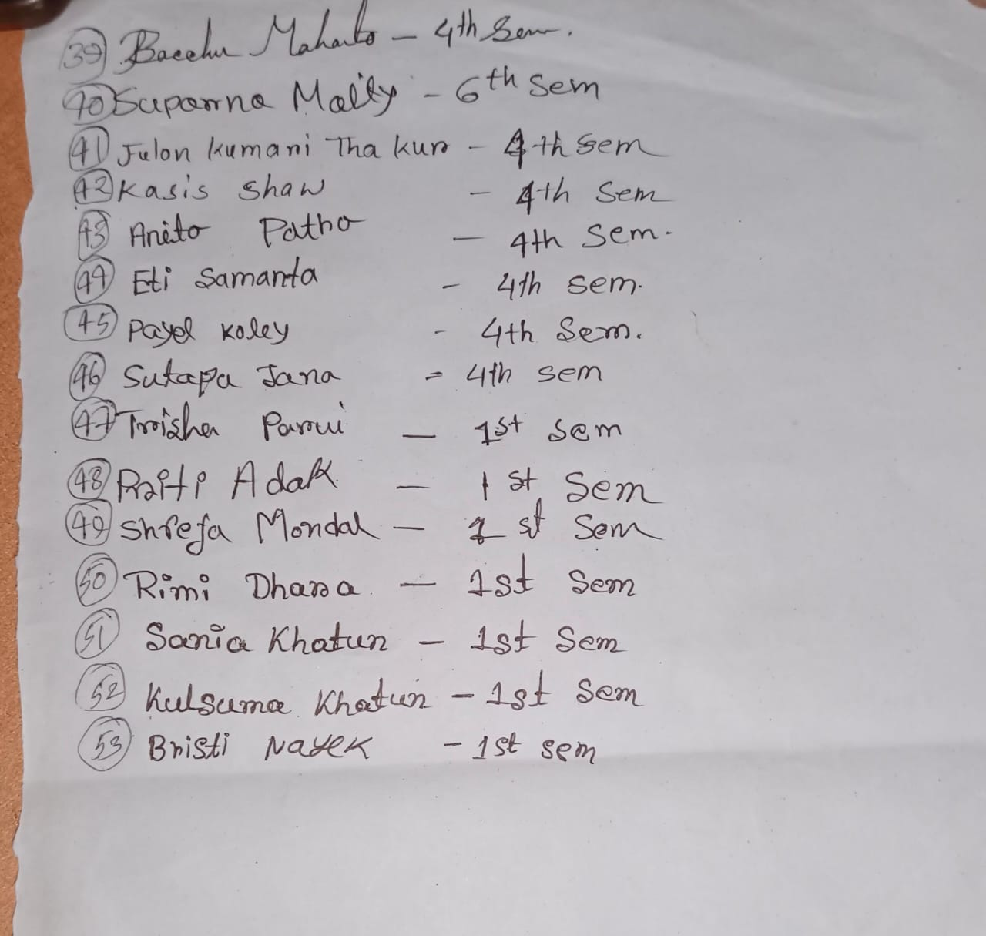

Attendance: 53
Male: 20
Female:35

Tentative programmed schedule:
- Student’s seminar: 11.30a.m. to 1.00 p.m.
- Lunch break: 1.00 p.m. to 1.30 p.m.
- Inaugural session: 1.30 p.m. to 1.45p.m.
- Inaugural speech:1.45p.m. to 2 p.m.
- Prize distribution: 2:30 p.m. to 2:45 p.m.
- Cultural programmed: 2 p.m. to 3:30 p.m.

Feedback Summary

- 48 responses (80%) received.
- 100 % felt satisfactory.
- 90% opined the event helped to improve their moral values/thinking

